LIST of commands part 1

1. Yum install python3-pip

2 pip3 install docker-compose

3 pip3 install --user docker-compose

4 systemctl enable docker.service

5 systemctl start docker.service

6 docker pull iamankush94/sre_assignment:latest

7 docker images

8 docker run -itd --name assignment 39b8 /bin/sh

9 docker ps

10 docker run -itd --name assignment2 D:/assignment/generated.csv:/home/node/app/generated.csv iamankush94/sre_assignment:latest

11 docker run -itd --name assignment2 D:/assignment/generated.csv:/home/node/app/generated.csv iamankush94/sre_assignment:latest /bin/sh

12 docker run -itd --name assignment2 -v D:/assignment/generated.csv:/home/node/app/generated.csv iamankush94/sre_assignment:latest /bin/sh

13 docker exec -it 5cf2 /bin/sh

14 ls -ltr

15 vi script.sh

16 sh script.sh

17 sh script.sh 2 10

18 ls -ltr

19 docker run -itd --name iamankush08 -v /root/generated.csv:/home/node/app/csv/generated.csv iamankush94/sre_assignment:latest

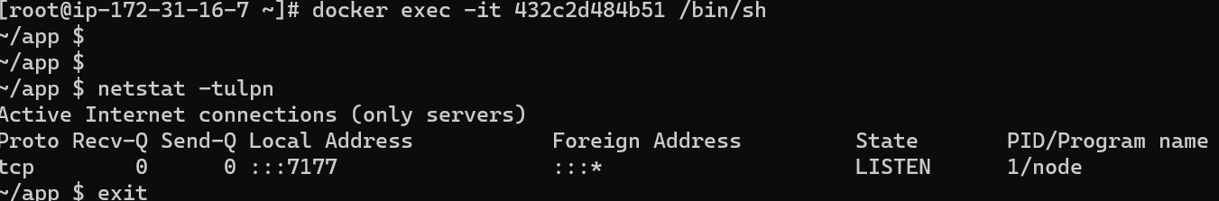

20 docker ps

21 docker exec -it 432c2d484b51 /bin/sh

22 docker stop $(docker ps -q)

23 docker rm 432c2d484b51

24 docker rm 5cf26b7eab76

25 docker run -itd --name iamankush08 -p 9393:7177 -e UI_COLOR="#0048CD" -v /root/generated.csv:/home/node/app/csv/generated.csv iamankush94/sre_assignment:latest

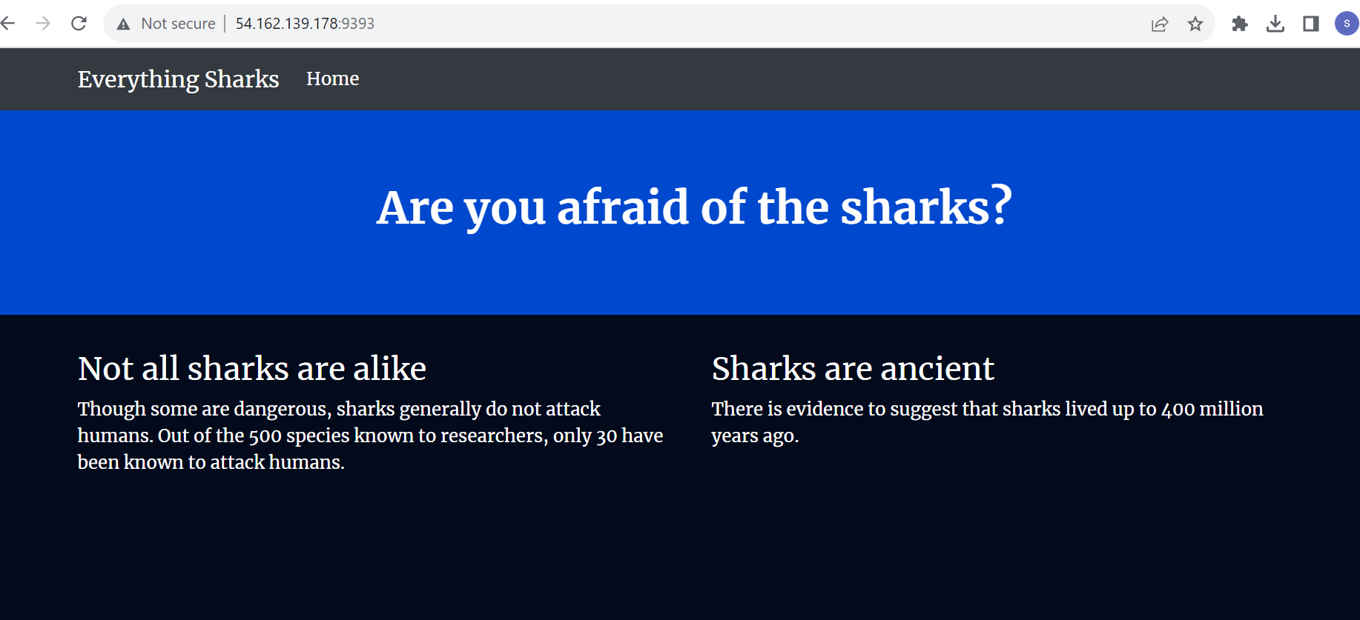

26 docker ps

27 history